**Description**

Tests located at: **Krieger_Code_Challenge** folder

Technologies used: *Java, Maven, TstNG, Extent Report, Selenium*

Project Structure:

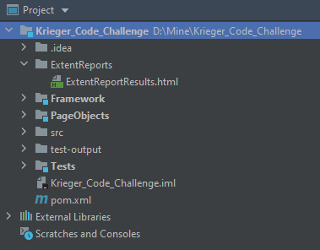

**Framework** module:

* krieger.framework.core contains BasePage.java and BaseTest.java classes
* krieger.framework.utilits contains ExtentManager.java and ExtentTestManager.java – implementation of Extent Report
* krieger.framework.listeners – listeners for Extent Report

**PageObject** module:

* LoginPage.java – implementation of the Login Page pageobject – contains locators for elements to interact, methods to operate with them.
* External.email.pageobject – contains Page Object for Gmail

**Tests** module:

* **tests.suite** package: VerifyConfirmationText.java – test for homework (mandatory)
* **extended.tests** package:
  + VerifySubscriptionViaEmail.java – test for confirming subscription (finishing registration process) – *Optional 2*
  + VerifyEmailError.java – test to verify that only email formatted text can be written in the ‘Ihre Email Addresse’ field – additional test
  + VerifyEmailAlreadySubscribed.java – test to check that user cannot subscribe more that one time with already registered email – additional test

**ExtentReport** folder contains ExtentReportResults.html:

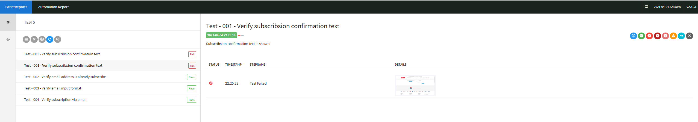

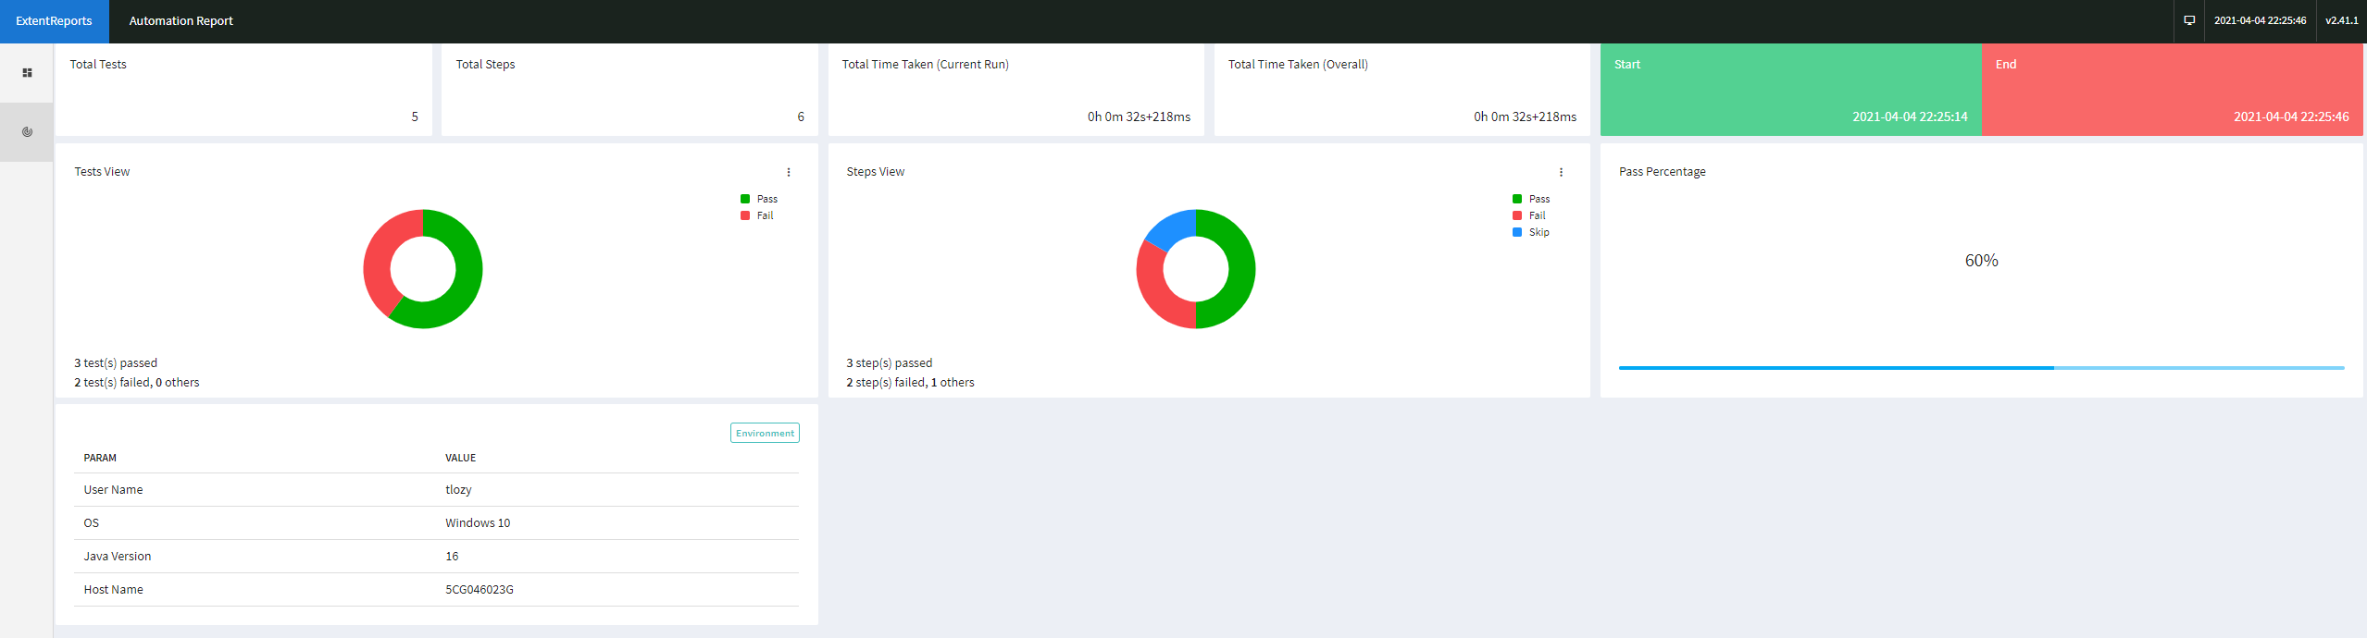

Optional1:

Scenarios that are not covered by existing test:

* Test to verify that only email formatted text can be written in the ‘Ihre Email Addresse’ field – *covered in ‘VerifyEmailError.java’ test*
* Test to check that user cannot subscribe more that one time with already registered email – *covered in ‘VerifyEmailAlreadySubscribed.java’ test*
* *Test that user can unsubscribe from the subscription*
* Verify received email sender – email is sent from correct address - *covered in ‘VerifyEmailAlreadySubscribed.java’ test*
* Verify received email subject – correct subject is shown - *covered in ‘VerifyEmailAlreadySubscribed.java’ test*
* Verify received email body content.

The mandatory scenario and missing ones could and should be automated. The tests should be the part of regression suite, also they are mandatory for testing new marketing offer/reoffer campaigns.